Precious Blood Volunteers
2019 Application

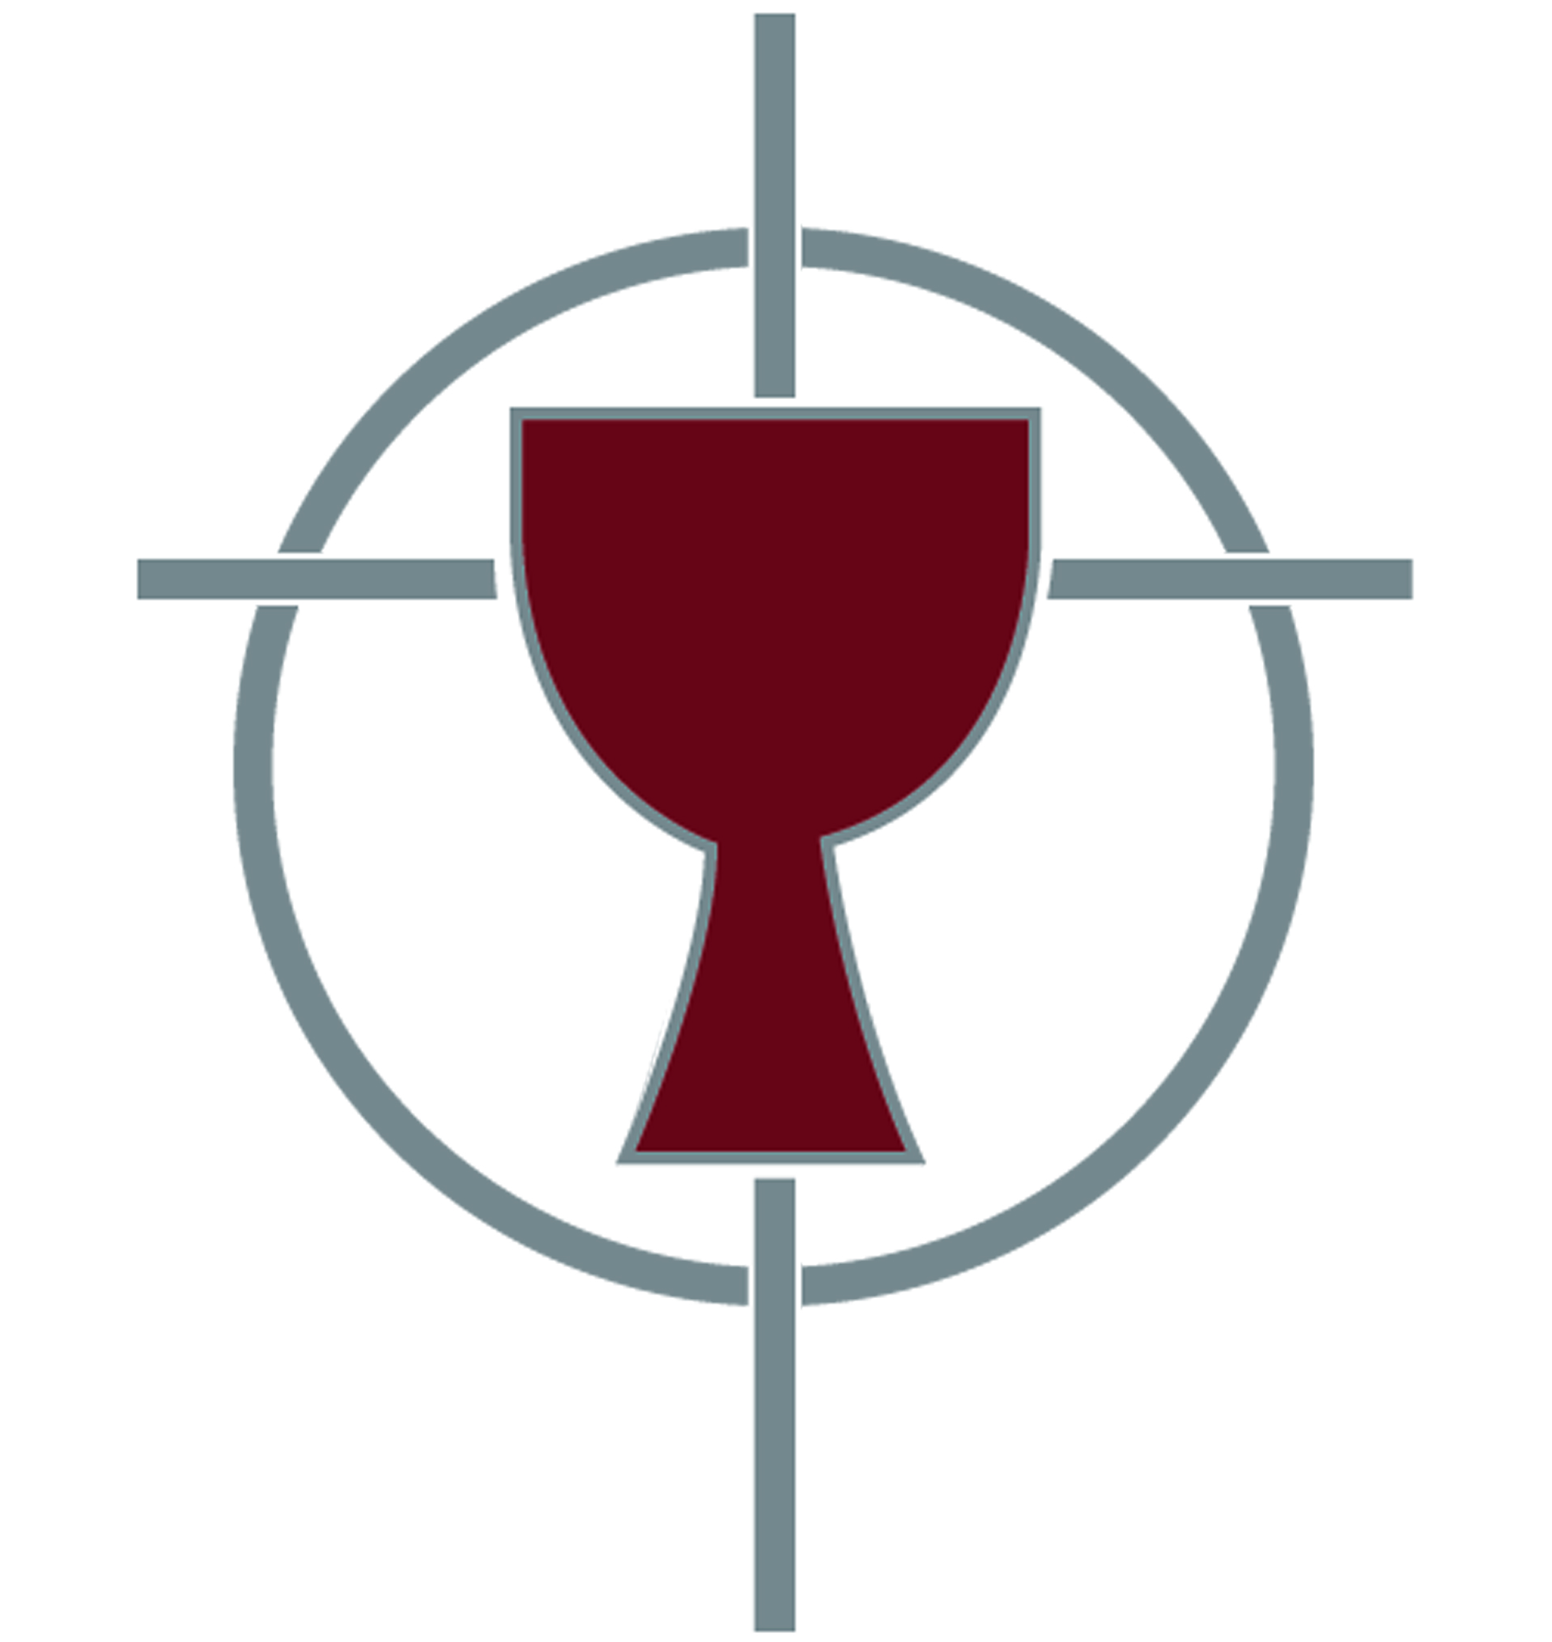

Grow in Faith
Build Community
Walk with those who Suffer
Seek Reconciliation

Thank you for applying to become a Precious Blood Volunteer!

Please return the completed application, along with your resumé, via email to
volunteers@preciousbloodkc.org.

For all questions please contact Tim Deveney, Director of Volunteers
by email at volunteers@preciousbloodkc.org
or by phone at 816-781-4344

Background Information
Full Legal Name:
Address (City, State, Zip):
Phone Number:
Email Address:

Which of our placements are you interested in? (Please check all that apply)
Place me where you think is best!
Precious Blood Ministry of Reconciliation (Chicago, Illinois)
Bishop Sullivan Center (Kansas City, Missouri)
Cristo Rey High School (Kansas City, Missouri)
Precious Blood Resource Services (Kansas City, Missouri)
KC CARE Health Center (Kansas City, Missouri)
Legal Aid of Western Missouri (Kansas City, Missouri)

Please list any languages you speak (besides English) and indicate your level of fluency in each one.
- Language
Level of Fluency: Beginner Intermediate Fluent

- Language
Level of Fluency: Beginner Intermediate Fluent

How did you hear about Precious Blood Volunteers? Please select all that apply.
Friend/Relative | Parish | Campus Ministry Office
Web Search | Google Ad | Social Media
Career Center | College Social Concerns/Justice Office
RESPONSE booklet | Catholic Volunteer Network Website
Other (Please list):

References
Please provide the names and contact information for three people (all non-relatives) who will be writing reference letters for you. One reference should be from a peer. The other two should be from people who have mentored, supervised, taught or directed you. Please share with them our reference form found at http://preciousbloodkc.org/pbv-apply/. They can send us a letter of recommendation in place of our reference form. Completed reference forms or letters of recommendation should be sent in directly by these people to us via email or US Mail to 2130 St. Gaspar Way, Liberty, MO 64068.

Reference #1
Name:
Phone Number:
Email Address:
Relationship:

Reference #2
Name:
Phone Number:
Email Address:
Relationship:

Reference #3
Name:
Phone Number:
Email Address:
Relationship:

Short Answer Questions
Please answer each question as completely as possible to help us get a good idea of who you are and your motivation to serve.

- Describe your relationship with God and the role of faith in your life.

- Write about a difficult situation you experienced with someone you lived with, how you handled the situation and if you had to do it over again how you could have handled the situation differently.

- What do you hope to get out of your experience in community living?

- Describe an experience (or experiences) you have had working or being with people who have been marginalized in our society. What drew you to this experience (or experiences)? Please include a reflection on how you were impacted by the experience.

- Why do you want to serve as a volunteer? Please describe what sparked this desire.

- What does the word “reconciliation” mean to you?

- What are some of the gifts you would bring as a Precious Blood Volunteer? In what capacity might you envision using these gifts?

- What are some hopes and expectations for your time as a Precious Blood Volunteer?

