Precious Blood Volunteers
2017 Application

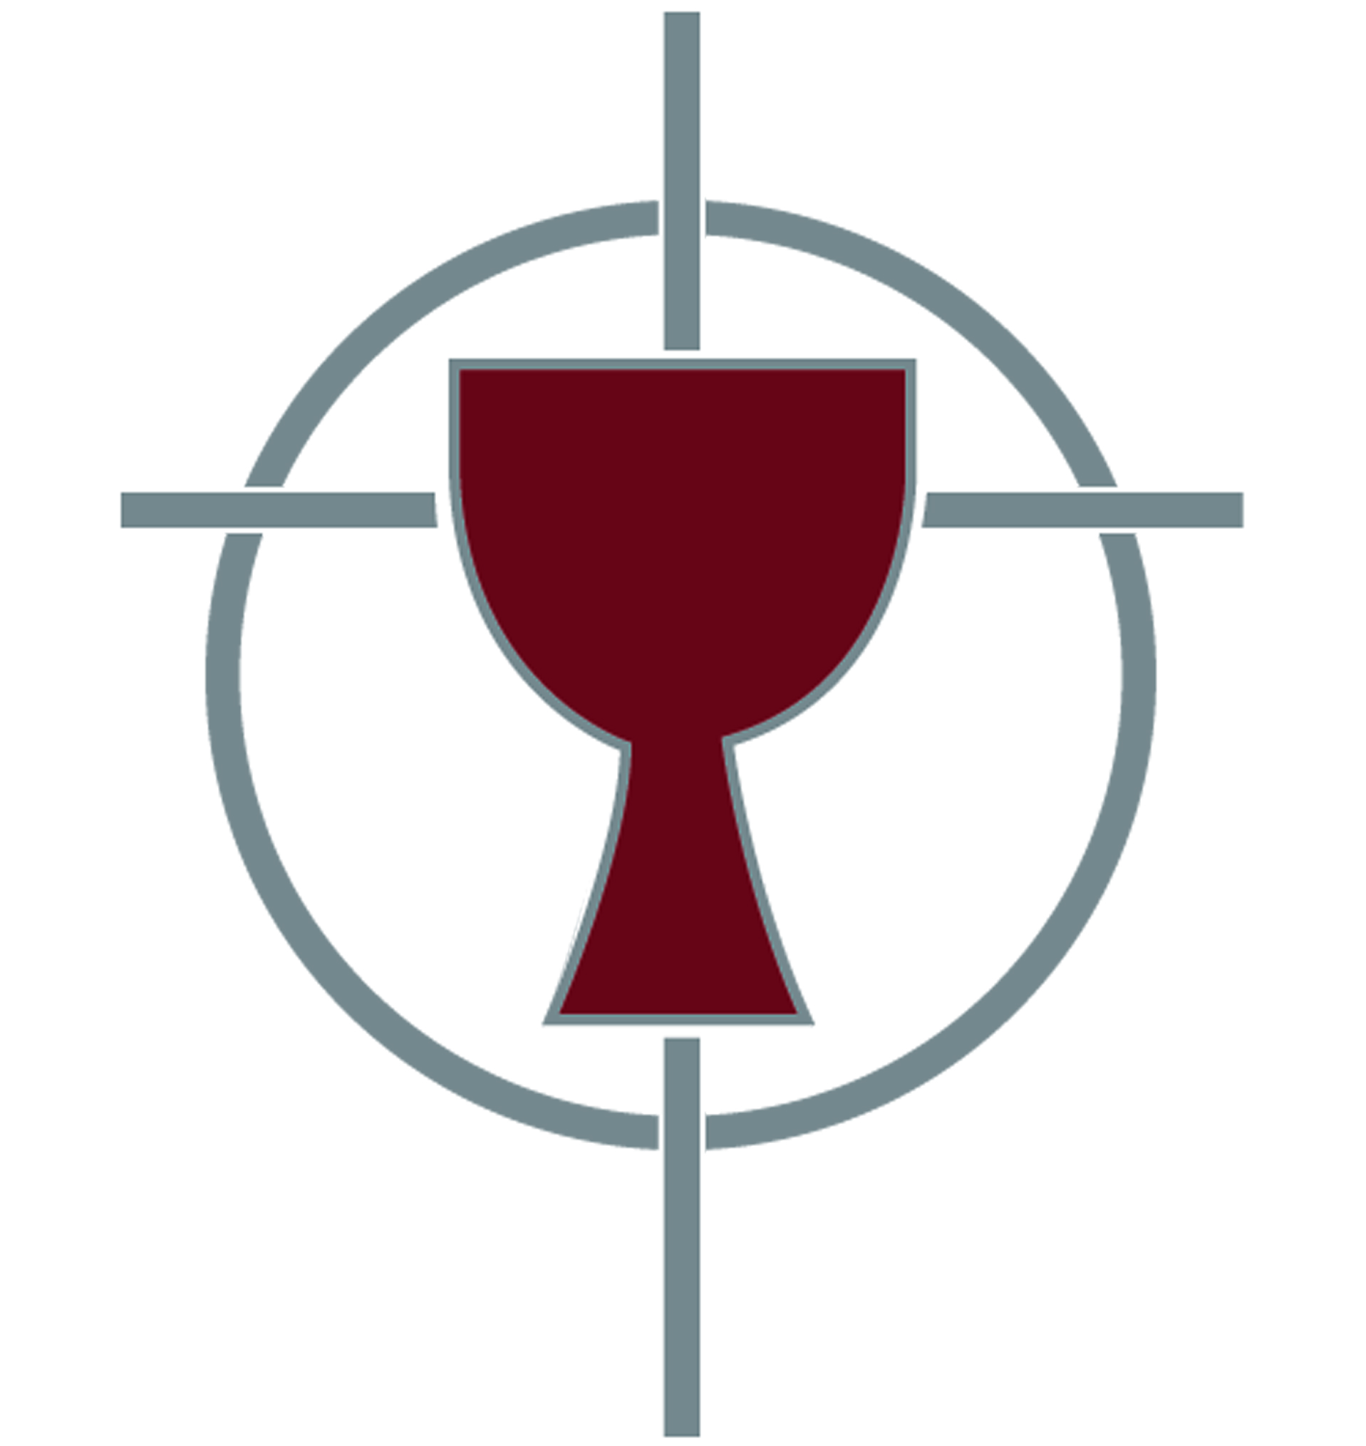

Grow in Faith
Build Community
Walk with those who Suffer
Seek Reconciliation

Thank you for applying to become a Precious Blood Volunteer!

Please return the completed application, along with your resume’, via email to
volunteers@preciousbloodkc.org.

You may send in a hard copy via U.S. Mail to
Precious Blood Volunteers
P.O. Box 339
Liberty, MO 64069-0339

For all questions please contact Tim Deveney, Director of Volunteers
by email at volunteers@preciousbloodkc.org
or by phone at 816-781-4344

Background Information
Full Legal Name:
Date of Birth:
Address (City, State, Zip):
Phone Number:
Email Address:
Please list all degrees you have received, or will have received by the time you begin serving as a Precious Blood Volunteer. Please be sure to list the institutions you received these degrees from:

Please list any languages you speak (besides English) and indicate your level of fluency in each one.
- Language
Level of Fluency: Beginner Intermediate Fluent

- Language
Level of Fluency: Beginner Intermediate Fluent

- Language
Level of Fluency: Beginner Intermediate Fluent

How did you hear about Precious Blood Volunteers? Please select all that apply.
Friend/Relative | Parish | Campus Ministry Office
Web Search | Google Ad | Social Media
Career Center | College Social Concerns/Justice Office
RESPONSE booklet | Catholic Volunteer Network Website
Other (Please list):

References
Please provide the names and contact information for three people (all non-relatives) who will be writing reference letters for you. One reference should be from a peer. The other two should be from people who have mentored, supervised, taught or directed you. Please share with them our reference form found at http://preciousbloodkc.org/pbv-apply/. Completed reference forms should be sent in directly by these people to us via email or US Mail to the addresses listed on the cover page.

Reference #1
Name:
Phone Number:
Email Address:
Relationship:

Reference #2
Name:
Phone Number:
Email Address:
Relationship:

Reference #3
Name:
Phone Number:
Email Address:
Relationship:

Short Answer Questions
Please answer each question as completely as possible to help us get a good idea of who you are and your motivation to serve.

- Describe your relationship with God.

- How do you pray?

- Write about a difficult situation you experienced with someone you lived with, how you handled the situation and if you had to do it over again how you could have handled the situation differently.

- What do you hope to get out of your experience in community living?

- Describe an experience (or experiences) you have had working or being with people who have been marginalized in our society. What was your motivation to work with these people? Please include a reflection on how you were impacted by the experience.

- Why do you want to serve as a volunteer? Please describe at least one experience that sparked this desire.

- What does the word “reconciliation” mean to you?

- What are some of the gifts you would bring as a Precious Blood Volunteer? In what capacity might you envision using these gifts?

- What are some hopes and expectations for your experience as a Precious Blood Volunteer?

